**Assignment 3**

**1. Explain the Linked list?**

Ans: A linked list is a sequence of data structures, which are connected together via links.

Linked List is a sequence of links which contains items. Each link contains a connection to another link. Linked list is the second most-used data structure after array

Linked List Representation

Linked list can be visualized as a chain of nodes, where every node points to the next node.

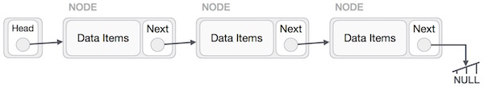

As per the above illustration, following are the important points to be considered.

* Linked List contains a link element called first.
* Each link carries a data field(s) and a link field called next.
* Each link is linked with its next link using its next link.
* Last link carries a link as null to mark the end of the list.

**2. Mention the types of linked list?**

Ans: Following are the various types of linked list.

* **Simple Linked List** − Item navigation is forward only.
* **Doubly Linked List** − Items can be navigated forward and backward.
* **Circular Linked List** − Last item contains link of the first element as next and the first element has a link to the last element as previous.

**3. What is the purpose of a Linked list?**

Ans: Applications or purpose of linked list in computer science –

1. Implementation of stacks and queues
2. Implementation of graphs : Adjacency list representation of graphs is most popular which is uses linked list to store adjacent vertices.
3. Dynamic memory allocation : We use linked list of free blocks.
4. Maintaining directory of names
5. Performing arithmetic operations on long integers
6. Manipulation of polynomials by storing constants in the node of linked list
7. representing sparse matrices

**4. Why use linked lists over arrays?**

Ans: Arrays and Linked Lists both are linear data structures, but they both have some advantages and disadvantages over each other.

One advantage of the linked list is that elements can be added to it indefinitely, while an array will eventually get filled or have to be resized (a costly operation that isn't always possible).

Elements are also easily removed from a linked list whereas removing elements from an array leaves empty spaces that are a waste of computer memory.

However, unlike arrays which allow random access to the elements contained within them, a link list only allows sequential access to its elements. Linked lists also use more storage space in a computer's memory as each node in the list contains both a data item and a reference to the next node.

It follows that linked lists should be used for large lists of data where the total number of items in the list is changing. Arrays, on the other hand, are better suited to small lists, where the maximum number of items that could be on the list is known.

**5. Explain circular linked list?**

Ans: Circular Linked List is a variation of Linked list in which the first element points to the last element and the last element points to the first element. Both Singly Linked List and Doubly Linked List can be made into a circular linked list.

Singly Linked List as Circular

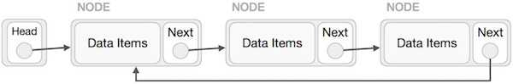

Doubly Linked List as Circular

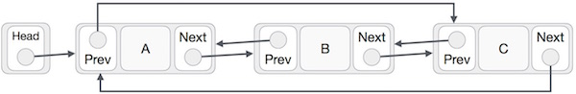

**6. How will you explain Circular Linked List?**

Ans: Circular linked list is a linked list where all nodes are connected to form a circle. There is no NULL at the end. A circular linked list can be a singly circular linked list or doubly circular linked list.

Circular Linked List

**Advantages of Circular Linked Lists:**  
**1)**Any node can be a starting point. We can traverse the whole list by starting from any point. We just need to stop when the first visited node is visited again.

**2)** Useful for implementation of queue. Unlike this implementation, we don’t need to maintain two pointers for front and rear if we use circular linked list. We can maintain a pointer to the last inserted node and front can always be obtained as next of last.

**3)** Circular lists are useful in applications to repeatedly go around the list. For example, when multiple applications are running on a PC, it is common for the operating system to put the running applications on a list and then to cycle through them, giving each of them a slice of time to execute, and then making them wait while the CPU is given to another application. It is convenient for the operating system to use a circular list so that when it reaches the end of the list it can cycle around to the front of the list.

**4)** Circular Doubly Linked Lists are used for implementation of advanced data structures like